CSC387 Lab 01

1. 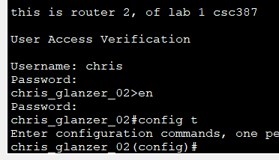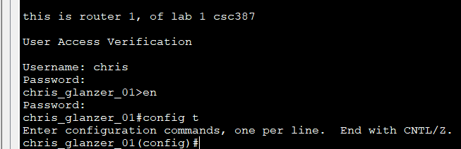**Verification step 1**
2. 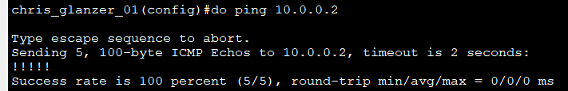**Verification step 2**
3. 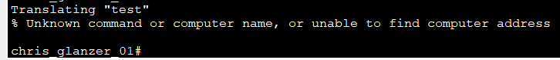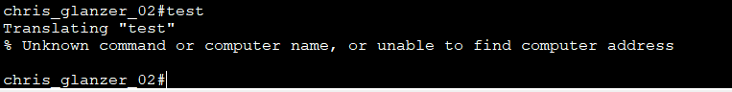**Verifica** **tion step 3**
4. 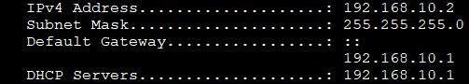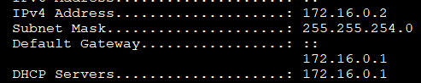**Verification step 4**
5. **Verification step 5**



1. **Verification step 6**

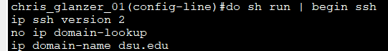

1. 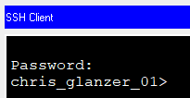**Verification step 7**